**UCS 2312 Data Structures Lab**

**Assignment 9: Graph Traversal and its Applications**

The cityADT consists of adjacency matrix that represents the connection between the cities. Adjacency matrix has an entry 1, if there is a connection between the cities.

Implement the following methods. [CO2, K3]

* void create(cityADT *C) – will create the graph using adjacency matrix
* void disp(cityADT *C) – display the adjacency matrix
* void BFS(cityADT *C) – provides the output of visiting the cities by following breadth first
* void DFS(cityADT *C) – provides the output of visiting the cities by following depth first

1. Demonstrate the ADT with the following Graph

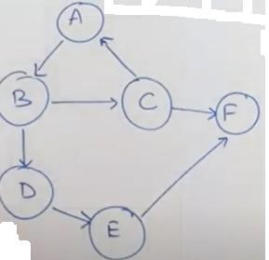

Enter the no. of vertices: 6

Enter the no. of edges: 7

AB, BC, BD, CA, CF, DE, EF

Adjacency Matrix

|  |  |  |  |  |  |  |
| --- | --- | --- | --- | --- | --- | --- |
|  | A | B | C | D | E | F |
| A | 0 | 1 | 0 | 0 | 0 | 0 |
| B | 0 | 0 | 1 | 1 | 0 | 0 |
| C | 1 | 0 | 0 | 0 | 0 | 1 |
| D | 0 | 0 | 0 | 0 | 1 | 0 |
| E | 0 | 0 | 0 | 0 | 0 | 1 |
| F | 0 | 0 | 0 | 0 | 0 | 0 |

**BFS Output:** ABCDFE for Start vertex A

**DFS Output:** ABCFDE for Start vertex A

1. Write an application to utilize traversals to do the following:

* 1. Given the source and destination cities, find whether there is a path from source to destination
  2. Find the connected components in a given graph

Test the application with the following Input:

Source: D Destination: F Output:

Path exists Input:

Source: F Destination: B Output:

Path not exists

Input:

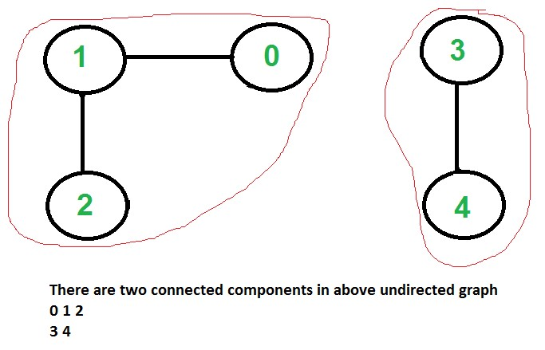

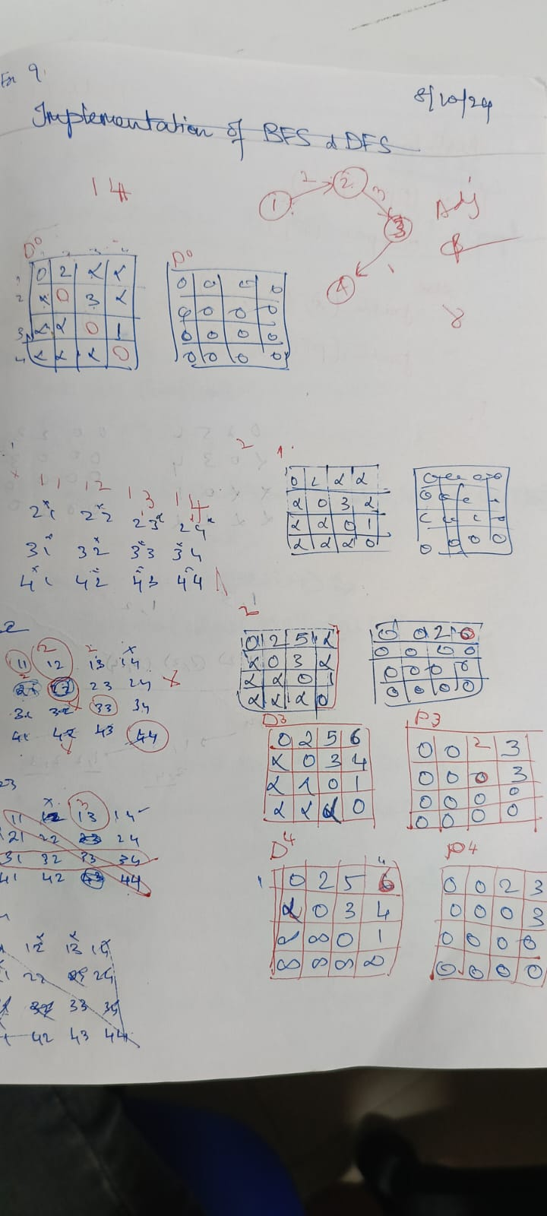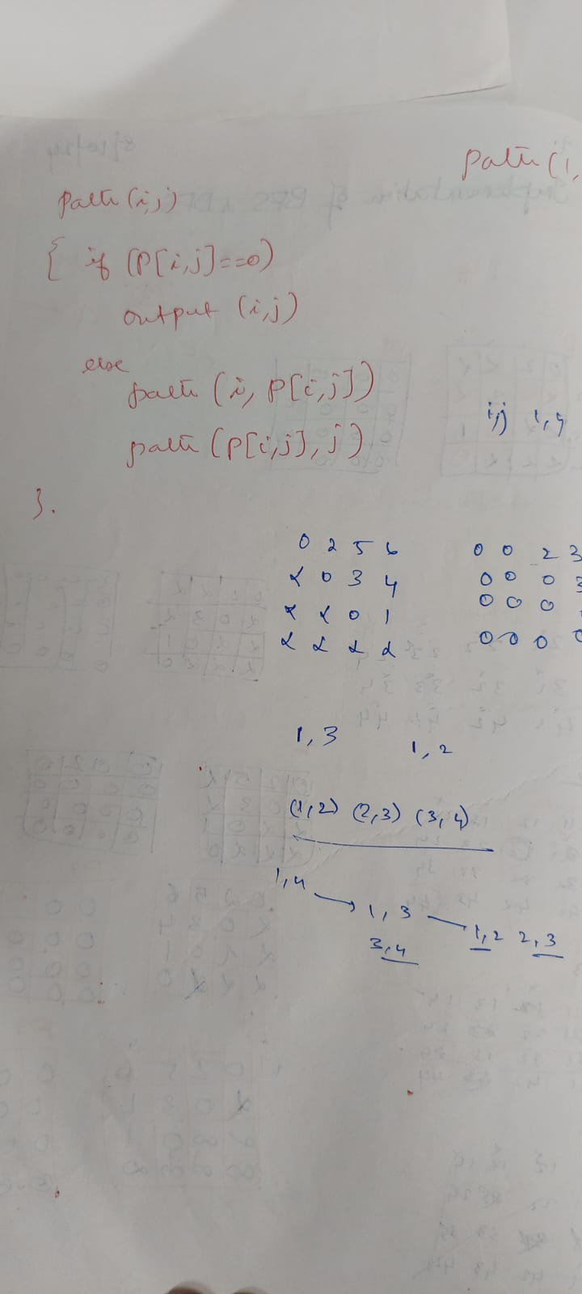

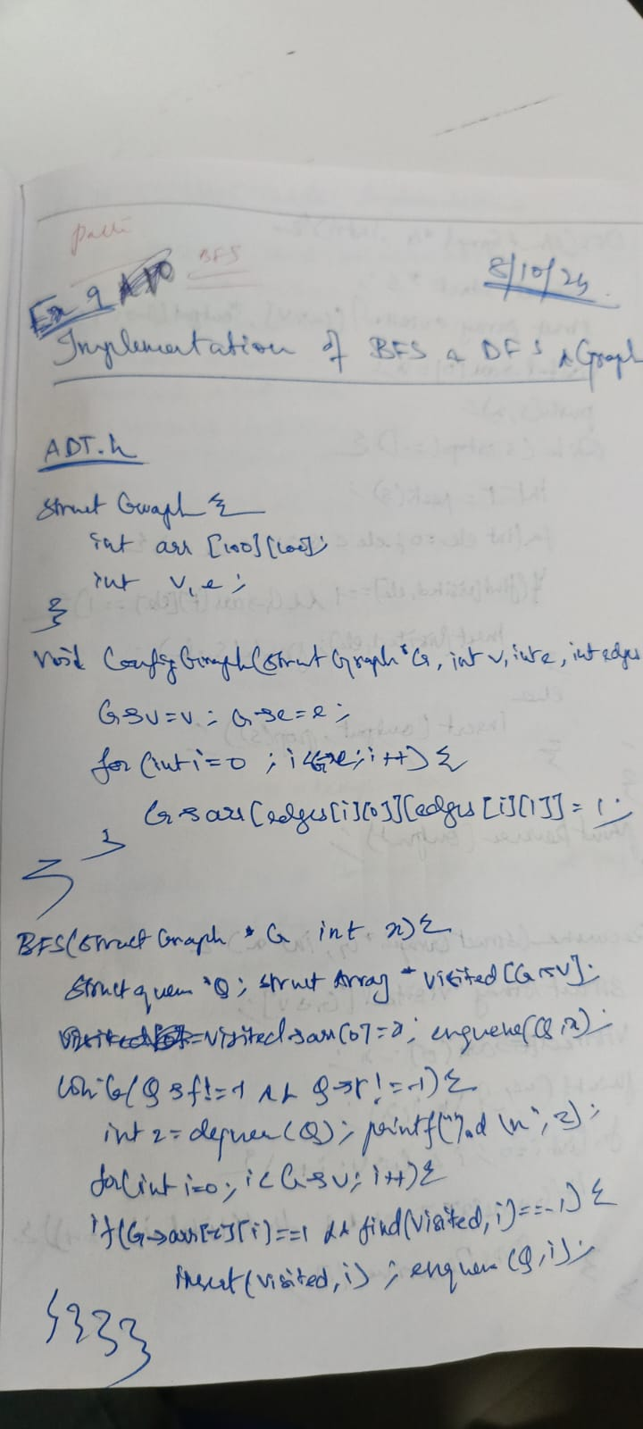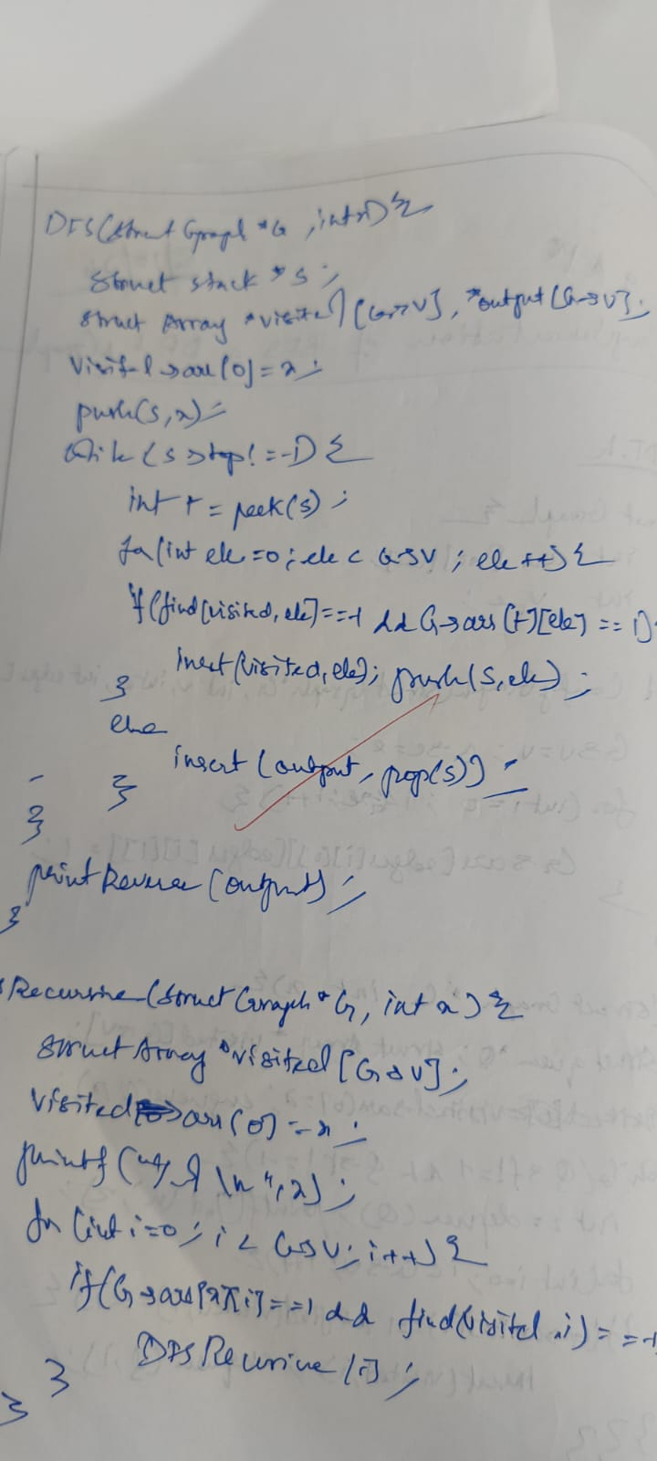

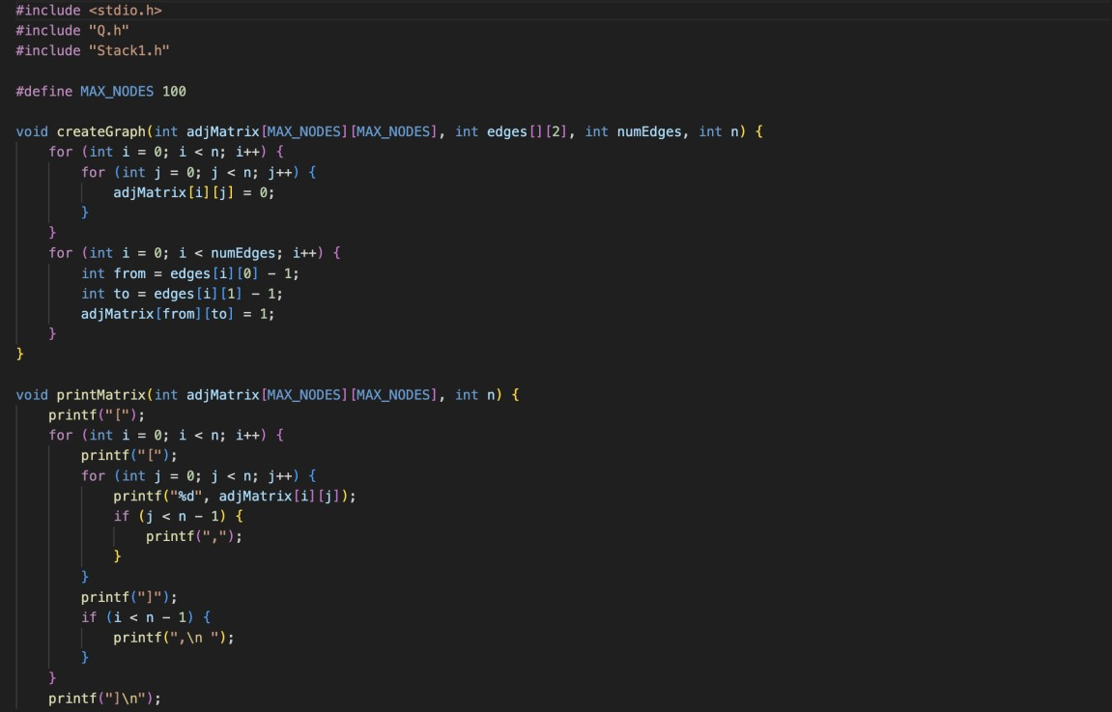

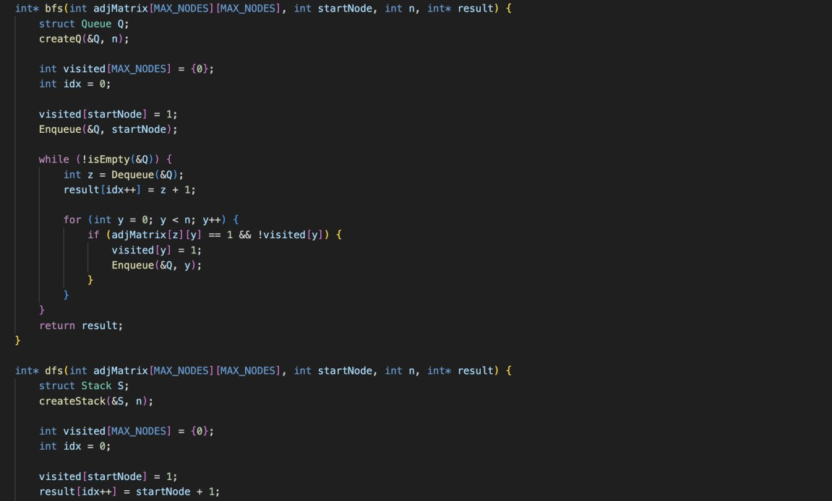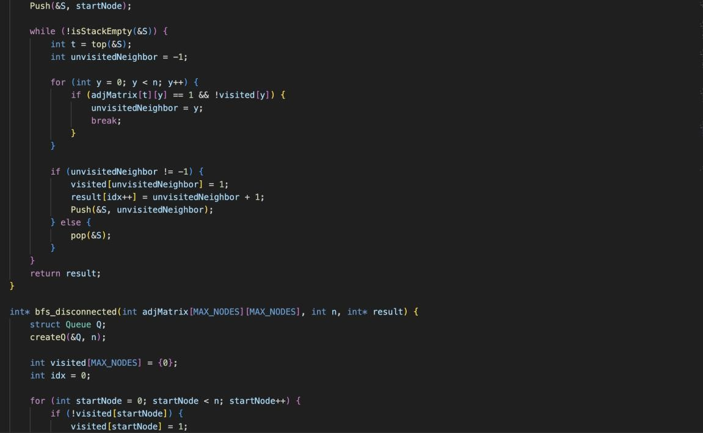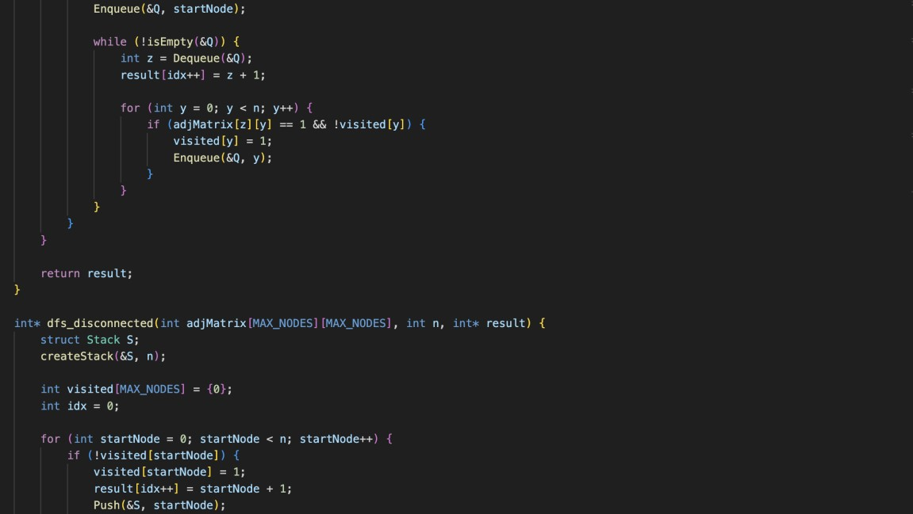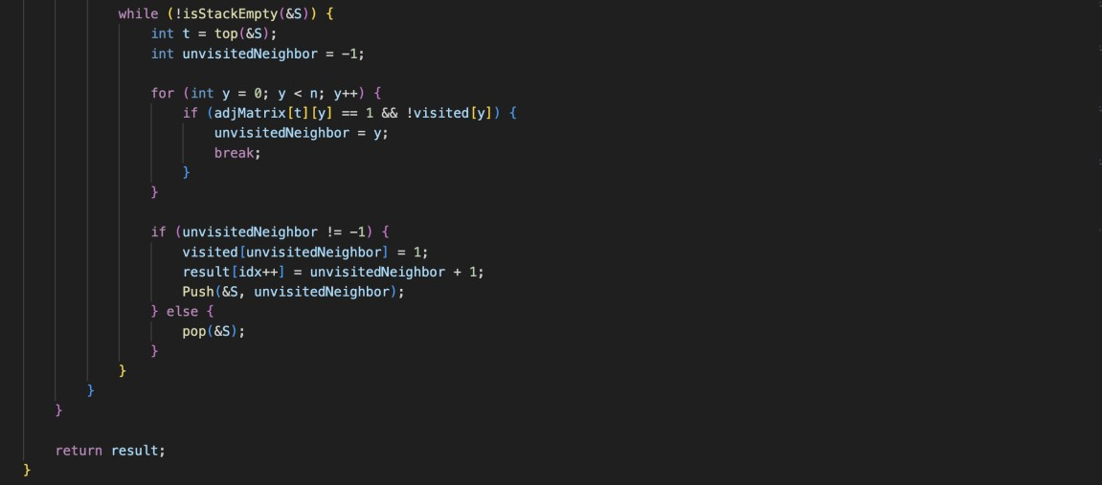

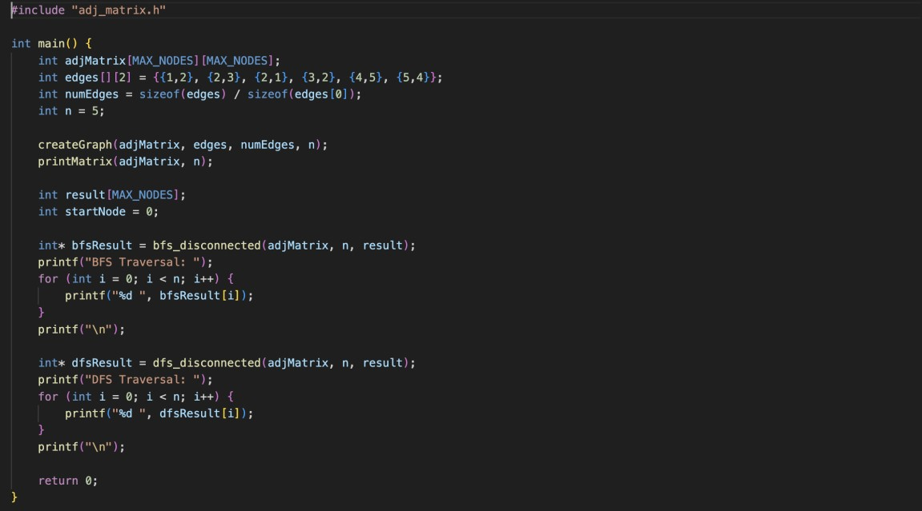

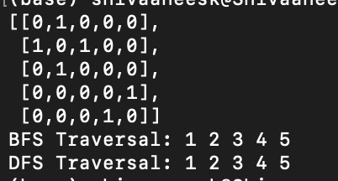

Technical Outcomes:

|  |  |  |
| --- | --- | --- |
| Design | 3 |  |
| Understanding DS | 3 |  |
| Usage of DS | 2 | Needs improvement |
| Debugging | 3 |  |

Best Practices:

|  |  |  |
| --- | --- | --- |
| Design before coding | 3 |  |
| Usage of algo | 3 |  |
| Multifile | 3 |  |
| versioning | 3 |  |